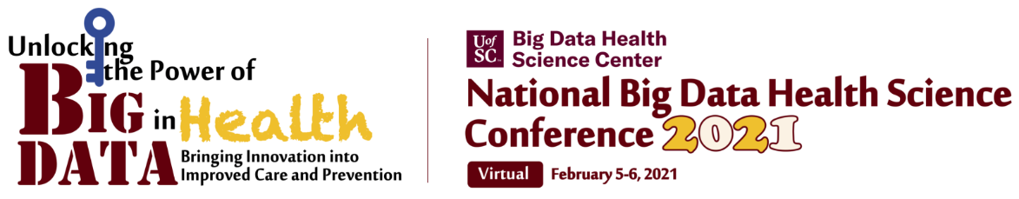

**1st Annual Big Data Health Science Case Competition Case January 29th – 31st, 2021**

**Ethics Statement of Compliance**

The General Rules for Big Data Health Science Case Competition states, “…no faculty or other professional assistance is allowed in solving the case.” Additionally, ethical standards require that copyright laws are followed and that there is no misrepresentation of someone else's work as that of the students.

The UofSC Big Data Health Science Case Competition is designed for only students and therefore, outside (non-team) support in solving the case (includes analyses, preparation of slides, and other activities) is not allowed. Advisors/faculty who are not members of the team may only be involved in providing feedback in practice presentation sessions before the presentation.

The printed names and signatures below acknowledge compliance with the above General Rules:

# Team Member #1:

# Team Member #2:

# Team Member #3:

# Team Member #4:

**\*Faculty Mentor/Advisor __**

**NOTE: This statement must accompany the team’s PowerPoint slide deck but do not add this as a slide – should be a separate document.**